Hong Kong Institute of Vocational Education

Department of Information and Communications Technology
Department of Multimedia & Internet Technology
ITP4507 - Contemporary Topics in Software Engineering
ITP4605 - Contemporary Topics in CSA

Laboratory Exercise 8 –Object Oriented Programming with JavaScript

Q1. Object Creation

- The simplest object oriented construct in JavaScript is it's built in Object data type. Write an HTML web page with JavaScript code to create an object called “cat” using new Object, and adds two properties to it. The following is a sample output of the web page.

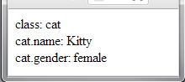

- Alternatively, write an HTML web page using object literal to create the object in Q1 (1).

Q2. Constructor and Class

- A class can be defined in JavaScript by writing a function as the constructor for the class. Write a function for constructing the class Cat with attributes name and gender. Write an HTML web page with JavaScript code to create a Cat object using the ‘new’ operator. Write public method(s) to set and get the properties of the class. The following is a sample output of the web page.

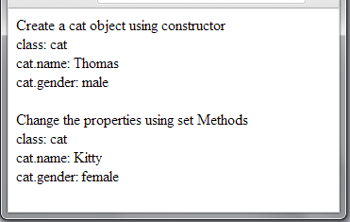

Q3. Prototype Chains, Dynamic Prototype Lookup and Function Prototype

- Every JavaScript object has an internal property called prototype (__proto__). The prototype chain works for the implementing ‘inheritance’ relationship. You are asked to use prototype (__proto__) to implement the following class diagram.

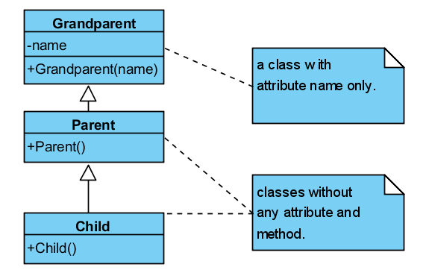

Write an HTML web page with above JavaScript code to implement the ‘inheritance’ relationship:

- Declare the constructors for the classes Grandparent, Parent, and Child.
- Create a Grandparent object with new Grandparent("anonymous") and store the object to variable elder.
- Create a Parent object with new Parent () and store the object to variable adult.
- Create a Child object with new Child () and store the object to variable kid.
- Set kid’s __proto__ to adult and adult’s __proto__ to elder.
- Display the objects’ name attribute in the console.
- Change the kid, adult and elder objects’ name attribute to ‘Chris’, ‘Bob’, ‘Andy’ respectively and display the objects’ name attribute in the console.
- The following is a sample output in the console.

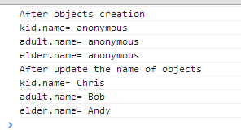

- Every function in JavaScript has a special property called ‘prototype’. The ‘prototype’ property points to the object that will be assigned as the prototype of instances created with that function when using ’new’. You are asked to use function prototype to implement the following class diagram.
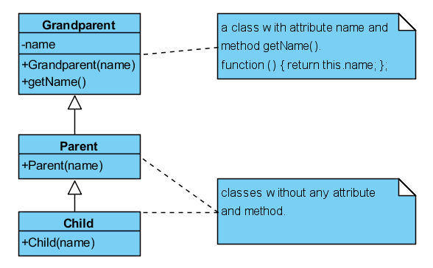
Write an HTML web page with above JavaScript code to implement the above ‘inheritance’ relationship:

- Declare three constructors for the classes Grandparent, Parent, and Child
- Declare the getName() method of the Grandparent class
- Create a Grandparent object with new Grandparent("anonymous") and store the object to variable elder.
- Set the prototype of Parent to elder.
- Create a Parent object with new Parent ("anonymous") and store the object to variable adult.
- Set the prototype of Child to adult.
- Create a Child object with new Child ("anonymous") and store the object to variable kid.
- Display the attributes of the kid, adult and elder objects
- Change the name attribute of the kid, adult, and elder objects to ‘Chris’, ‘Bob’, ‘Andy’ respectively and display the objects’ attributes in the console. You should use the method getName() to retrieve the name attributes and the sample output in the console is exactly the same as in Q3 (1).

Q4. Classical Inheritance using Prototype Chain and The extend Function

- JavaScript can be made to look like a classically inherited language. By using functions to declare classes, and the new keyword to create instances. You are asked to use prototype chain to implement the following class diagram.
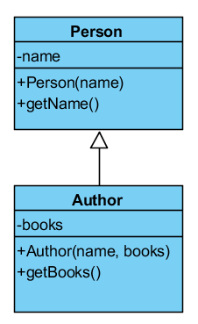
Write an HTML web page with JavaScript code to implement the above ‘inheritance’ relationship.

- Write the constructors and methods for the two classes (Person and Author).
- Set the prototype of Author to the Person object.
- Use the constructors to create objects. Create an object (name='John Smith') of Person class. Create two objects of Author class. Use an array to store these two objects. The names of the two objects are 'Dustin Diaz' and 'Ross Harmes' while the books of the two objects are the same, ['JavaScript Design Patterns'].
- Display the objects’ attributes in the console. You should use the get method to retrieve the attributes and the following is a sample output in the console.

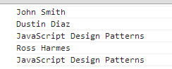

- In order to make the class declaration more simple, you can wrap the whole subclassing process in a function, called extend. It will do what the extend keyword does in other languages—define a subclass from a given class. You are asked to use the extend function (given in the lecture notes) to implement the class diagram in Q4 (1).

- Write the constructors and methods for the two classes (Person and Author).
- Use the extend function to implement the above ‘inheritance’ relationship.
- Use the new commands to create objects. Create an object (name='John Smith') of Person class. Create two objects of Author class. Use an array to store these two objects. The names of the two objects are 'Dustin Diaz' and 'Ross Harmes' while the books of the two objects are the same, ['JavaScript Design Patterns'].
- Display the objects’ attributes in the console. You should use the get methods to retrieve the attributes of the objects. The sample output in the console is exactly the same as in Q4 (1).

